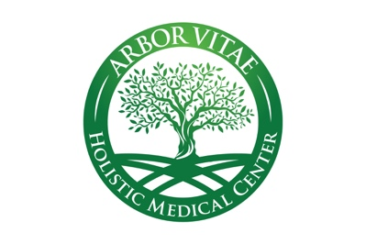

FAQ

What is functional medicine?

Functional medicine is an investigative process that addresses the underlying causes of disease, using a systems-oriented approach and engaging both patient and practitioner in a therapeutic partnership. Whereas conventional medicine asks, “What drug can we use to combat the symptoms of this disease?”, functional medicine asks, “Why do we have this problem in the first place, and how can we restore optimal function?”

Whether you are looking to optimize your wellness to prevent problems in the future or need to address a current health issue, the functional medicine process can help.

Do you accept insurance?

As a membership-based clinic, we do not accept insurance. This allows us to practice unencumbered by the restrictions imposed by insurance companies, and provide the best and most comprehensive care possible.

Can I use my insurance for labs?

Yes, in some cases, depending on the lab. Some labs accept and bill insurance and some do not. We will submit insurance for testing whenever possible.

What does it cost to be a patient, and what does it include?

Membership fees are simple. There is a one-time onboarding fee of $600 which includes an initial consultation and evaluation with a nutritional therapist, and thereafter the monthly fee is $150. The first month is prorated and you must sign on for a minimum of 6 months. After 6 months you may choose to continue your membership, transition to a less frequent visit plan, or discontinue membership.

Services included in membership:

- Initial comprehensive functional medicine analysis, history and physical exam
- Initial comprehensive nutritional evaluation visit with France trained chef and nutritional therapist Carol Green from Taste of Healing
- Initial follow up visit to review lab results and initiate treatment plan
- Monthly follow up visits to evaluate progress and make adjustments to the treatment plan as needed
- Communication via text, video chat and email

Labs and supplements are not included in membership and are additional costs. Supplements are available at significant discounts from retail and labs not covered by insurance are provided at wholesale costs.

What ages do you see?

We currently accept patients ages 5 years and up.

Do you prescribe regular medications?

Yes, we prescribe regular medications when needed. Although our aim is to use natural treatments when possible, we value and utilize conventional medicine when appropriate.

Other services

Acute care visits for illness or injury offered as availability allows for $79/visit. Sports/camp/work physicals are also offered for $79/visit.

How do I know if AVH is the right choice for me?

We offer free 15 minute consultations in which you can meet the provider and get all your questions answered before deciding to proceed with membership or book an appointment. We are a relationship-based practice, and as such want to ensure that everything is a good fit before embarking on this journey of health together.

